**Week 1 Excel: Supplemental Material**

### **Microsoft Excel**

Go to the course website and download the files:

1. Week1-Excel-Supplemental-Instructions.pdf
2. Week1-Excel-Supplemental-Data.xlsx

**S.1.1 Excel: Navigation Demo**

Data: Use the Navigation worksheet for this exercise.

Objective: Naming cells or ranges of cells allows you to refer to data by name.

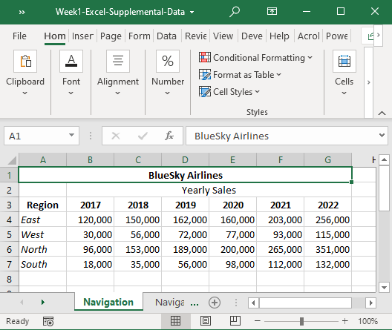

1. To name a cell range, such as A3:G7, as YearlySales:
   1. Highlight cells A3 through G7
   2. Click on the Formulas tab at the top of the screen
   3. Under Define Name, click on Define Name
   4. Type in YearlySales as the range name, then click OK

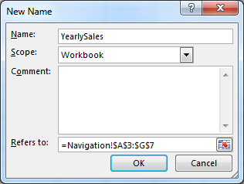

1. Alternatively, you can highlight the range, then type in YearlySales where you see A3 with a dropdown arrow above the data but below the “Clipboard.”

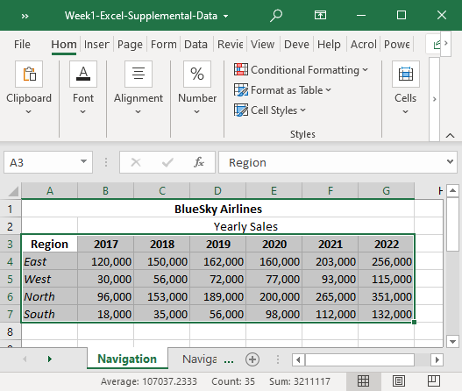

**S.1.2 Excel: Calculations and Formulas Demo**

Data: Use the Formula worksheet for this exercise.

Objective: Create permanent calculations and formulas, copy formulas, and check formulas with the audit feature.

1. Highlight the four sales values for 2022. Notice at the bottom of the page, it calculates the average, count, and sum of the values.

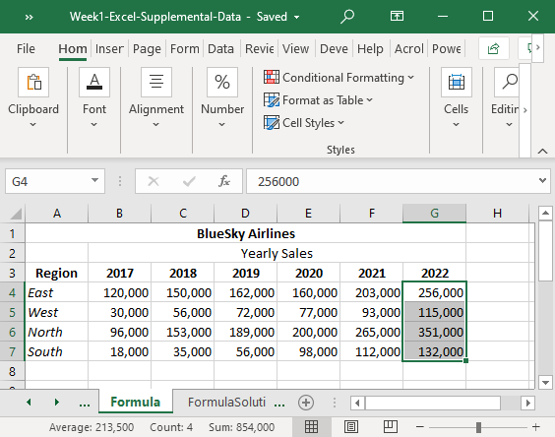

1. Next, we’ll enter a formula in the spreadsheet to automatically calculate averages and sums
2. In cell A9, type the word Average; also enter Average in I3
3. In cell A10, type the word Sum; also enter Sum in J3
4. To calculate a formula, use the equal sign, the name of the formula, and the data range
5. In cell B9, enter =average(b4:b7)
6. In cell B10, enter =sum(b4:b7)
7. In cell I4, enter =average(b4:g4)
8. In cell J4, enter =sum(b4:g4)
9. Notice that after you type the equals sign and part of the formula name, it gives you several options that start with the same spelling; you can click on the one you want, then highlight the range of data

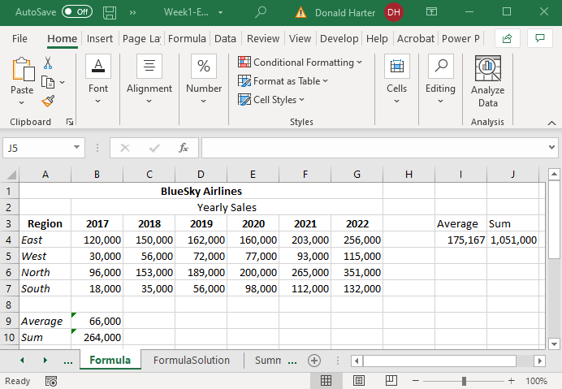

**Copy and paste formulas**

1. Copy and paste works the same in Excel as in Microsoft Word, but you can also copy and paste formulas and Excel will automatically update formulas
2. Copy the average and sum formulas across all columns and rows
   1. Click on cell B9
   2. A small dot will appear in the lower right corner of cell B9
   3. Put your cursor over the dot and it changes to a plus sign
   4. Click on the plus sign, hold the left mouse button down and drag to G9

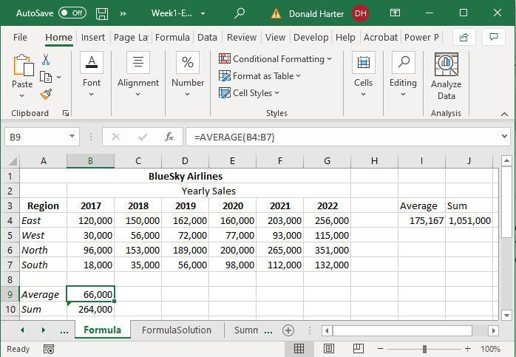

* 1. Copy cell B10 across for the columns in the same way

1. You can copy several formulas at once.
   1. Highlight cells I4 and J4
   2. A small dot will appear in the lower corner of the two cells I4:J4
   3. Put your cursor over the dot and it changes to a plus sign
   4. Click on the plus sign, hold the left mouse button down, and drag to row 7

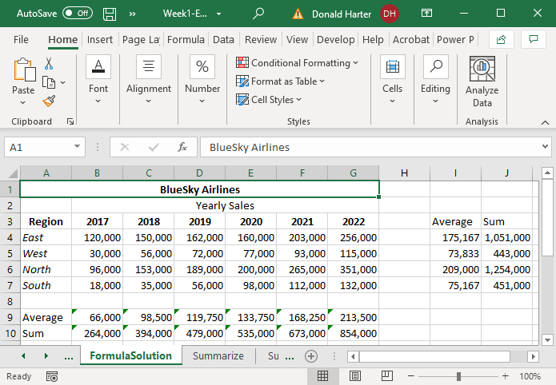

**Checking Formulas**

1. You can view formulas by clicking on the tab Formulas, then Show Formulas

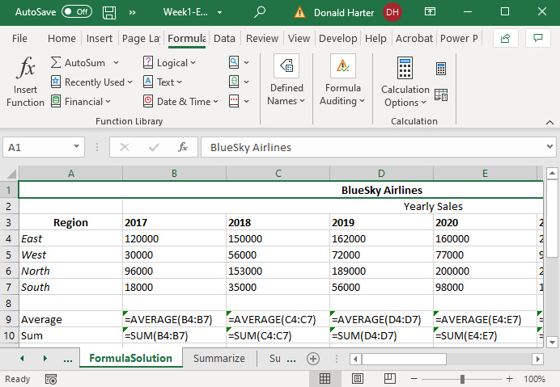

1. Excel has an auditing feature to check formulas; click on the tab labeled Formulas
2. Click on B9, then click on Trace Precedents in Formula Auditing
3. The box represents the data that goes into the formula; the arrow points to the formula
4. To clear the arrows, click on Remove Arrows

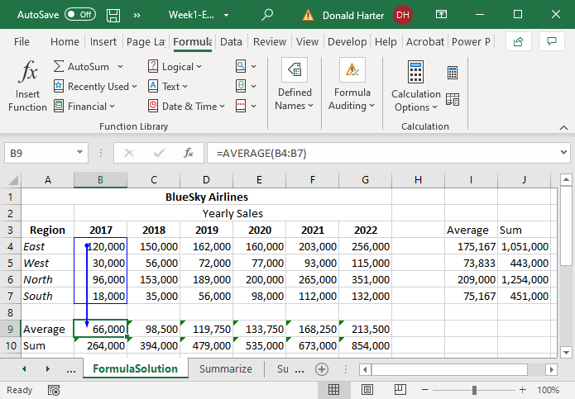

1. Click on B4, then click on Trace Dependents in Formula
2. The box represents the data that goes into the formula; the arrow points to the formulas
3. To clear the arrows, click on Remove Arrows

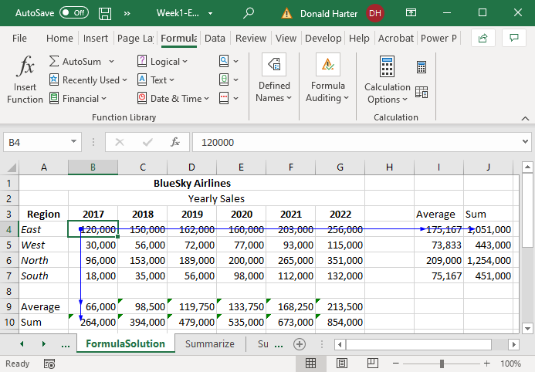

**S.1.3 Excel: Summarizing with Sparklines and Conditional Formatting Demo**

Data: Use the Summarize worksheet for this exercise.

Objective: Create miniature trend graphs and add conditional formatting to data.

1. A sparkline is miniature graph next to trend data
   1. To create a sparkline of the sum of yearly sales, highlight cells B10:G10
   2. On the Insert tab, click Sparklines, Line
   3. Enter H10 in Location Range, then OK

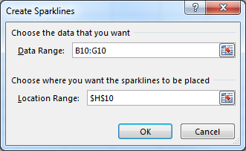

1. Similarly create sparklines for the average sales by year in cell H9

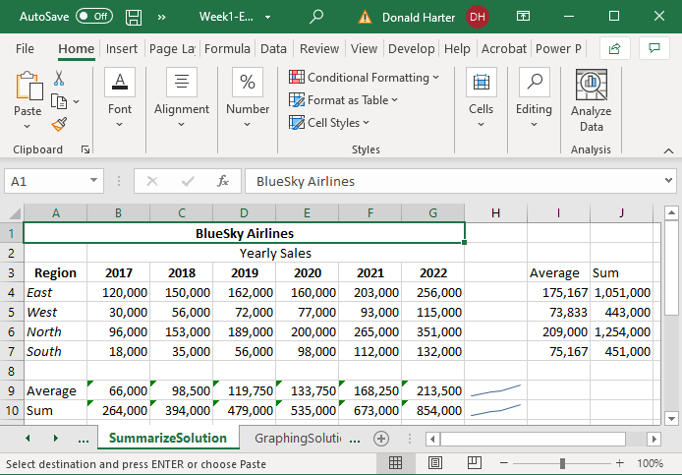

1. Conditional Formatting allows data to be highlighted by colors or icons
   1. Again, using the Summarize data for BlueSky Airlines, highlight sales in cells B4:G7
   2. Click on the Home tab
   3. Click on Conditional Formatting, Color Scales
   4. Alternatively, try Data Bars and Icon Sets

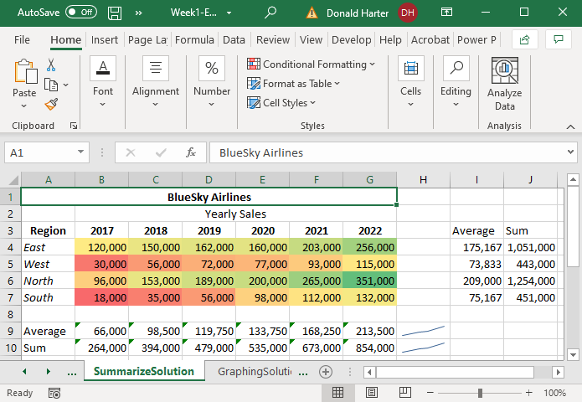

**S.1.4 Excel: Graphing and Visualization**

Data: Use the SummarizeSolution spreadsheet tab for this exercise.

Objective: Create graphs to visualize data.

1. Highlight the data by clicking on the cell labeled A3 through G7.
2. Next click on the Insert tab at the top of the screen.
3. In the section labeled Charts, click on the tiny icon in the lower right corner of charts to bring up the possible chart options.
4. Move the cursor over each option and select the 3-D column chart, then click OK.

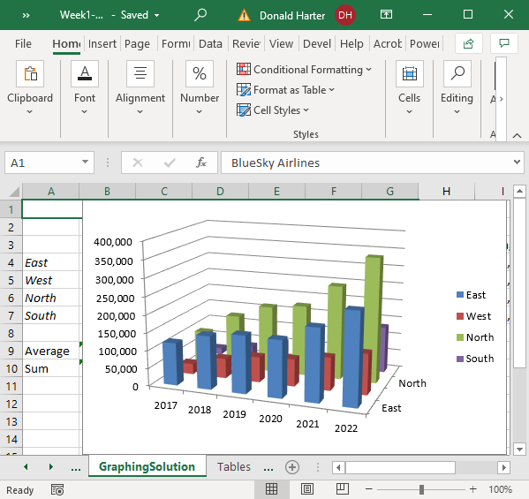

1. Let’s move the chart to another sheet. Click on the upper right corner of Excel, select Move Chart Location, click on New Sheet, then OK.
2. At the top of the screen click on Type, Change Chart Type to change the type of chart.
3. In the Chart Tools: Design: Data, click on Switch Row/Column. What happens? This is a toggle switch—click once and it switches rows and columns, click again and it switches back.
4. In the Chart Layouts: Quick Layout, there are several options (scroll down). How are they different? Options include adding numbers to the top of the bars, adding a table below the graph, etc.
5. Next, try Chart Tools: Design: Add Chart Element. Experiment with Labels and Axes. You can change the title, axes labels, etc.

**S.1.5 Excel: Tables Demo**

Data: Use the Tables worksheet for this exercise.

Objective: Create tables which allow you to format and organize data.

**Create and Manage Tables**

1. To create an Excel Table from a set of data, highlight the data by clicking anywhere in the data, then press Control A.
2. For Excel to correctly format your data as a table, the columns and rows must be contiguous. That is, there cannot be any blank columns or rows in the table area.
3. Click on the Home tab, and under Styles, click on Format as Table, select your color scheme, then confirm the data range. Check that your data has labels at the top and that the box for My table has headers is checked. Click OK.

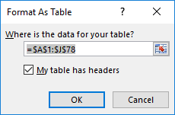

1. The table will have your color selection and will also have drop down arrows for filters.

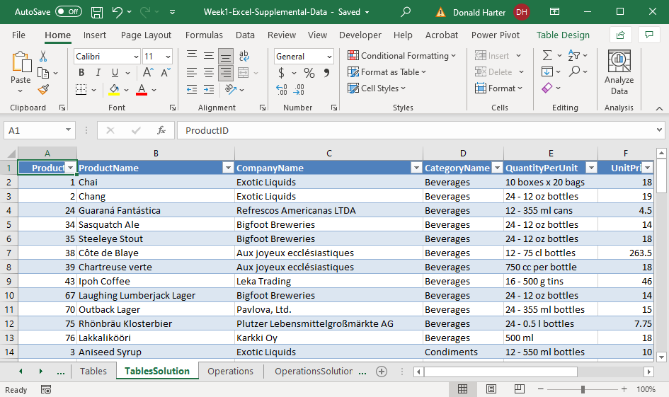

**Manage table styles and options**

1. Use the Table Tools – Design tab at the top of the screen to change the style of the table.
2. In the Design tab, Table Style Options, click on First Column, Last Column, or Banded Columns to change the formatting
3. To add a Total Row:
   1. Click on the Total Row box
   2. Scroll down to the bottom of the data
   3. Notice that the Total label is listed but not the numbers
   4. Click on cell F79 across from Total and under UnitPrice
   5. A drop-down arrow will appear; for this one, select Average, just as an example
   6. Excel will identify how to calculate the total, when possible, but when it is not sure, it will require you to make the selection

**Filter and sort a table**

1. Filter records by using the drop-down arrows on the header row. For example, select Exotic Liquids from the Company Name column.

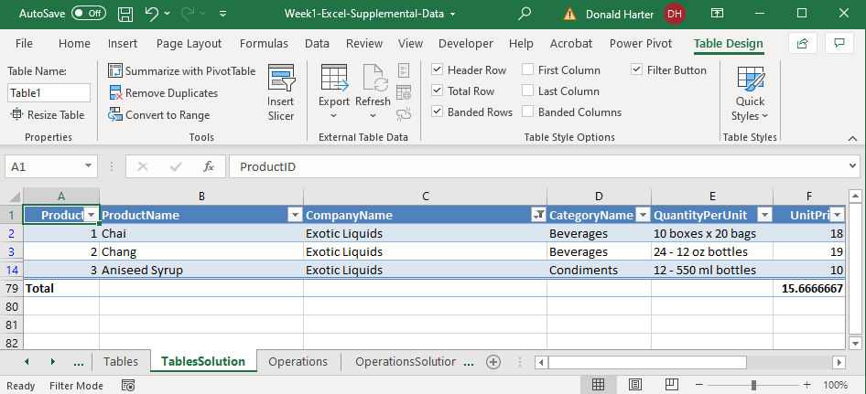

1. To sort the data, use the drop-down arrows to select the sorting option (A to Z, Z to A, smallest to largest, largest to smallest) to sort on Units in Stock.
2. To remove duplicate records, go to the Design Tab, Tools section, and click on Remove Duplicates

**S.1.6 Excel: Math and Text Operators Demo**

Data: Use the Operations worksheet for these exercises.

Objective: Math and text operators allow you to manipulate data via calculations, text functions, and if statements.

**Summarize data by using functions**

1. The functions SUM and AVERAGE were used earlier, but let’s create a variety of calculations on the Operations data
2. In cell E80, type in the word SUM
3. In cell G80, enter the formula =sum(G2:G78) to calculate the sum of Units in Stock
4. In cell E81, type in the word AVERAGE
5. In cell G81, enter the formula =average(G2:G78)
6. In cell E82, type in the word MIN
7. In cell G82, enter the formula =min(G2:G78)
8. In cell E83, type in the word MAX
9. In cell G83, enter the formula =max(G2:G78)
10. In cell E84, type in the word COUNT
11. In cell G84, enter the formula =count(G2:G78)

**Perform conditional operations by using functions**

* 1. IF statement
     1. The IF statement can test whether a condition is true or false, and return an answer. The portions of an IF are the condition, the answer if the condition is true, and the answer if the condition is false. The structure is =IF(condition, result if true, result if false)
     2. In cell E86, type IF
     3. In cell G86, type =IF(G83>G82,”Yes”, “No”)
  2. SUMIF
     1. SUMIF combines the SUM calculation with an IF condition
     2. In cell E87, type SUMIF
     3. In cell G87, type =SUMIF(D2:D78, “Seafood”, G2:G78)
     4. SUMIF compares your criteria (Seafood) to the labels in D2:D78, and only Sums the G column where Seafood appears in the D column
  3. AVERAGEIF – like SUMIF, but calculates the average
  4. COUNTIF – like SUMIF (with the first two arguments), calculates the count
  5. There are variations on each of these which allows multiple conditions (expert level)
     1. SUMIFS – multiple criteria for a sum
     2. AVERAGEIFS – multiple criteria for an average
     3. COUNTIFS – multiple criteria for a count

**Format and modify text**

1. The RIGHT function strips off the right most characters of a text string.
   * 1. In cell B80, type RIGHT
     2. In cell D80, type =right(D78,4) to get the four right-most characters
2. The LEFT function strips off the left most characters of a text string
   * 1. In cell B81, type LEFT
     2. In cell D81, type =left(D78,3) to get the three left-most characters
3. The UPPER function makes everything upper case
   * 1. In cell B82, type UPPER
     2. In cell D82, type =upper(D78)
4. The LOWER function makes everything lower case
   * 1. In cell B83, type LOWER
     2. In cell D83, type =lower(D78)
5. The PROPER function creates initial capitals
   * 1. In cell B84, type PROPER
     2. In cell D84, type =proper(D78)
6. The CONCATENATE function combines a group of text or number fields
   * 1. In cell B85, type CONCATENATE
     2. In cell C85, type =CONCATENATE(B78,C78,D78)
     3. Alternatively, you could type =B78&C78&D78
7. The TRIM function eliminates leading and trailing blanks
   1. In cell B86, type TRIM
   2. In cell D86, type =trim(B78)

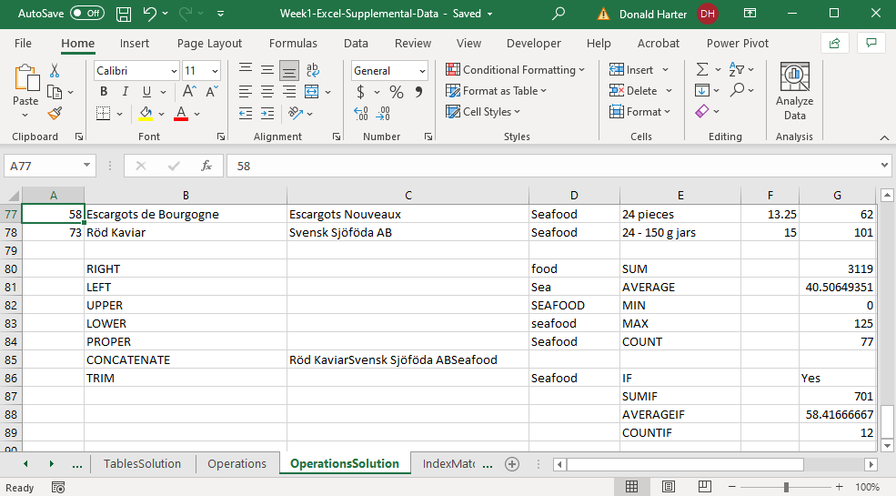

**S.1.7 Excel: Index and Match Demo**

Data: Use the IndexMatch spreadsheet for this exercise.

Objective: The match function identifies the cell in a column or row which matches a specific user supplied value. The index function, given a row and column, returns the value in a table. This combination will look up entered values, identify the appropriate columns and rows in a table, and return the appropriate value from the table.

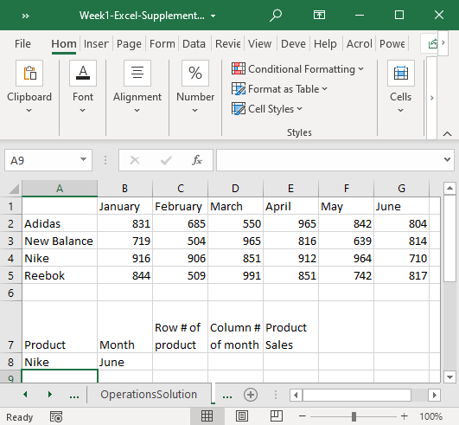

**MATCH**

Purpose: The Match function searches an array and finds a matching value.

The match function takes the form:

=match(lookup value, lookup range, match type)

Where: lookup value is the value you are trying to match

lookup range is the range to be searched

match type can take on the values:

1: data in ascending order, returns the row location of the largest value in the range less than or equal to the lookup value

-1: descending order, returns the row location of the last value in the range that is greater or equal to the lookup value

0: returns the row location of the first exact match

In the pictured example above, let’s find the row and column for Nike June sales automatically.

1. To make this a general procedure, note that Nike in entered in A8 and June is entered in B8.
2. Now enter the formula for the row in C8. Since we are searching for the row number of Nike, the formula would be =match(A8, A2:A5, 0). Why are we setting the last value to zero? The zero in the last parameter ensures an exact match.

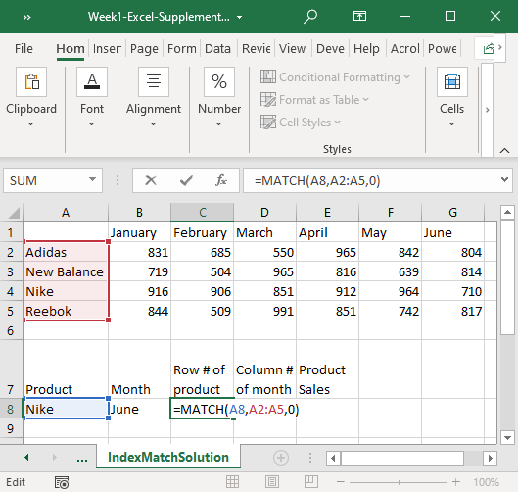

1. Enter the formula for the column in D8. The formula would be =match(B8, B1:G1,0)

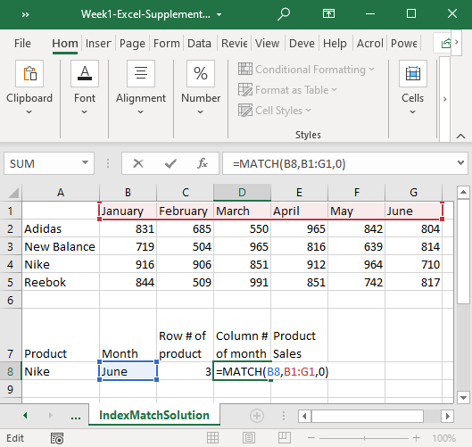

**INDEX**

Purpose: Index takes an array, row number, and column number, and retrieves the corresponding cell value from the array using the row and column numbers.

The command for index is:

=index(array, row number, column number)

Where: array is the data only

row number is the number within the array, not the spreadsheet

column number is the number within the array, not the spreadsheet

To identify cell value of a specific column and row, use the following steps:

1. In cell E8, enter the formula

=index(B2:G5,C8,D8)

1. Where
   1. B2:G5 is the array of sales data
   2. C8 is the row to be retrieved
   3. D8 is the column to be retrieved

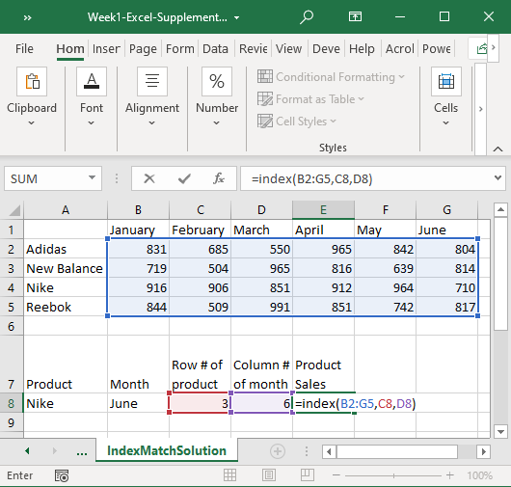

1. In cell A8, change brand from Nike to Adidas. Does the Product Sales value update?
2. In cell B8, change the month from June to March. Does the Product Sales update?